Coffee County FFA Membership Form
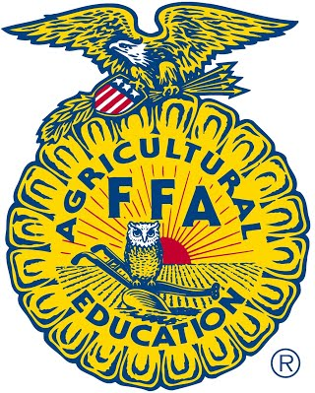
FFA (Future Farmers of America) is the largest national organization for students preparing in careers in agriculture or other related fields. FFA prepares students for real world professional experiences. Members gain the competitive edge for college and career successes. FFA will provide youth with travel opportunities, competitions, scholarships, leadership development, community service, friendship and FUN! All students enrolled in agriculture education classes are members and eligible for all the benefits and opportunities offered through FFA.

Full Name: __________________________________________ Date of Birth: ______________
Phone Number: ____________________ Email: ______________________________________
Address: ______________________________________________ City: ___________________
Grade: _________ Gender: __________ T-Shirt size: ___________

Are you interested in participating in extra-curricular activities through FFA? Yes No Maybe

What is your agriculture experience or SAE (supervised agricultural experience): __________
_____________________________________________________________________________

Parent/Guardian Information
Name: ___________________________
Numbers: Cell phone: ___________________
Work: _______________________
Home: _______________________
*Attach proof of insurance*
**Please complete the Media Consent Form on the back.**

Coffee County FFA Chapter
Parental/Legal Guardian Media Consent Form

I hereby consent to the use of any photographs/video taken of my child by the Coffee County FFA Chapter or the media for the purpose of advertising or publicizing events, activities, facilities and programs of the Coffee County Agriculture Department in newspapers, newsletters, website, other publications, television, radio and other communications and advertising media.

By law, the Coffee County FFA Chapter protects the privacy of the students and is prohibited from releasing students’ personal information.

From time to time representatives of the news media are invited to campus to cover events at our schools. When this happens, there is a possibility your child/children may be photographed, videotaped, or interviewed for a news story.

Please mark one of the choices below and return to school.

_____ Yes, I allow my child/children to be identified in any news or school publication.

_____ No, I do not want my child/children identified in any news or school publication.

PLEASE PRINT

Student’s Name:_______________________________________________________________

Signature:___________________________________________________________________

Parent or Guardian if above person is under 18:

Parent/Guardian’s Name:________________________________________________________

Signature:___________________________________________________________________

